|  |
| --- |
| Experiment No. 2 |
| Basic gates using universal gates. |
| Name: Shubham Sanjay Mohanty |
| Roll Number: 30 |
| Date of Performance: |
| Date of Submission: |

**Aim -** To realize the gates using universal gates.

**Objective -**

1. To study the realization of basic gates using universal gates.
2. Understanding how to construct any combinational logic function using NAND or NOR gates only.

**Theory -**

AND, OR, NOT are called basic gates as their logical operation cannot be simplified further.

NAND and NOR are called universal gates as using only NAND or only NOR, any logic function can be implemented.

**Components required -**

1. IC’s 7400(NAND) 7402(NOR)

2. Bread Board.

3. Connecting wires.

**Circuit Diagram -**

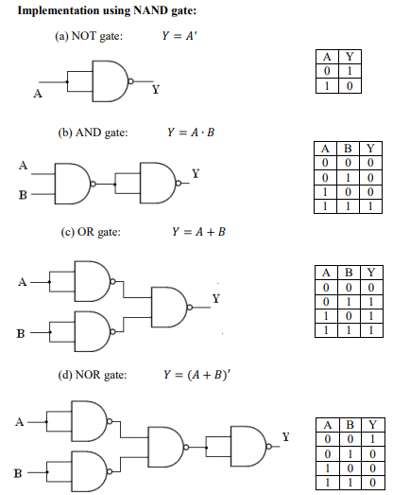

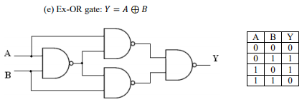

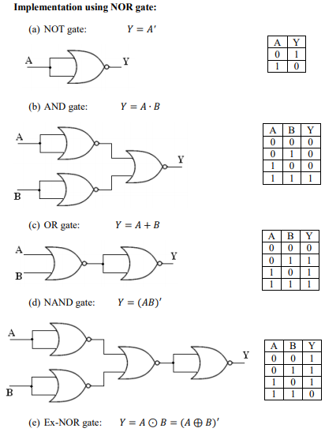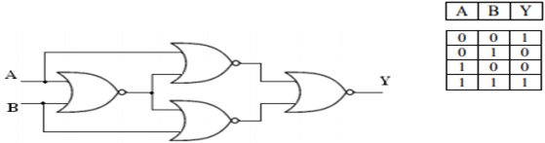

**Procedure:**

a) Connections are made as per the circuit diagrams.

b) By applying the inputs, the outputs are observed and the operations are verified with the help of truth table.

**Output:-**

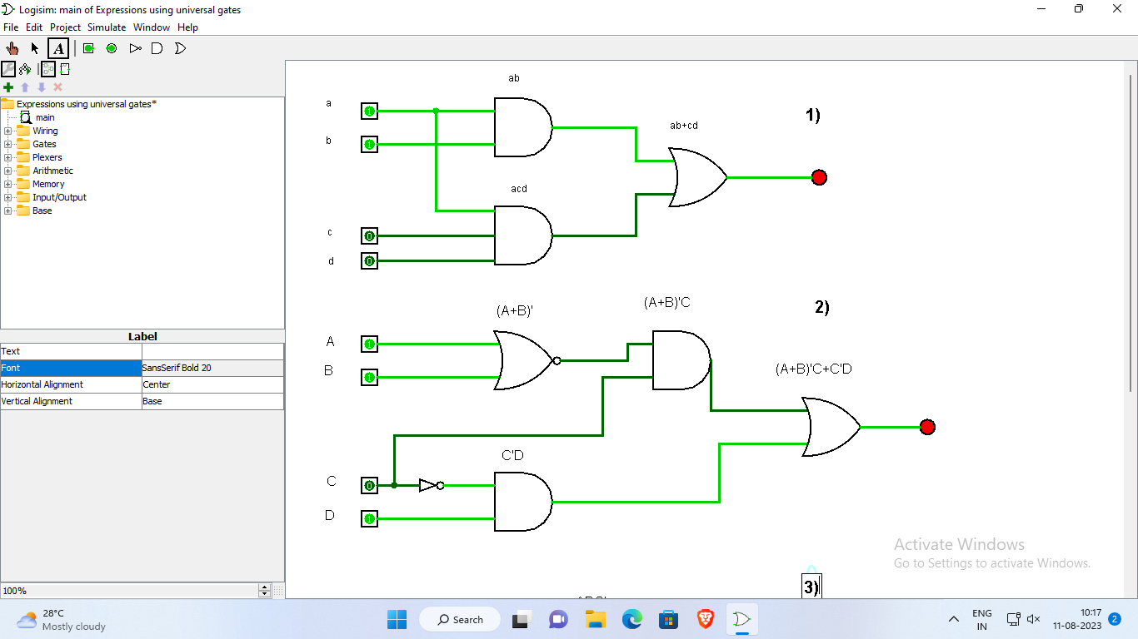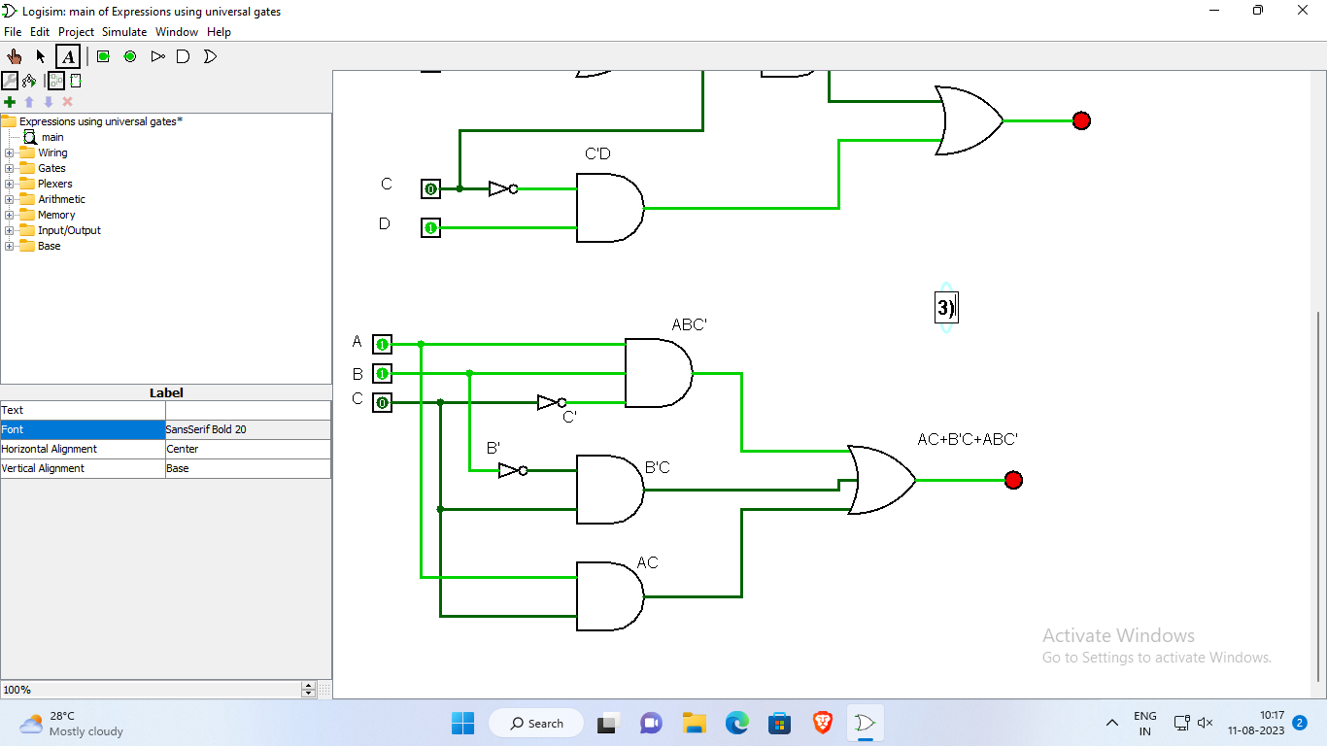

**Conclusion** –

The experiment conducted on universal gates in Logisim has provided valuable insights into the versatility and functionality of these essential digital logic components. We have demonstrated the ability of universal gates to perform a wide range of logical operations, showcasing their significance in modern digital circuit design. This experiment underscores the importance of understanding and utilizing universal gates in the field of digital electronics, paving the way for more efficient and versatile circuitry.